**Software Engineering Challenge**

**Requirements**

Describe the challenge or problem, what does the program need to do

To make a city with an animation

What classes/objects do you think you need?

Building class

How much time do you think you will you need to complete the project?

1 1/2 weeks

**Research**

What knowledge or skills will you need to build this program

I need to know how to thread and use applets within the program.

What examples are online or in other graphical programs (games, apps etc. . .)

Minecraft, Roblox.

If so, what can you learn from them?

They have a lot of good code with very nice graphics.

Do you foresee any problems or constraints, describe

Have you created a similar programs or applets? Are there similar programs in the book or other resources?

I did the stick figure program in class.

If so, what elements of that project can you bring to this project?

I can use the threading I learned in the stick figure programs in class.

Do you have the resources you need to create the program?

Yes, I have a computer and TextPad.

Do you need to learn any new knowledge or skill(s) to create the program?

Maybe, I might need to learn some other things for special effects.

**Design**

Draw/create a basic graphic of the applet you plan to build - attach the drawing

(paint, word, photo shop) not every objet (draw one example although there may be several in the final program) needs to be in the basic graphic

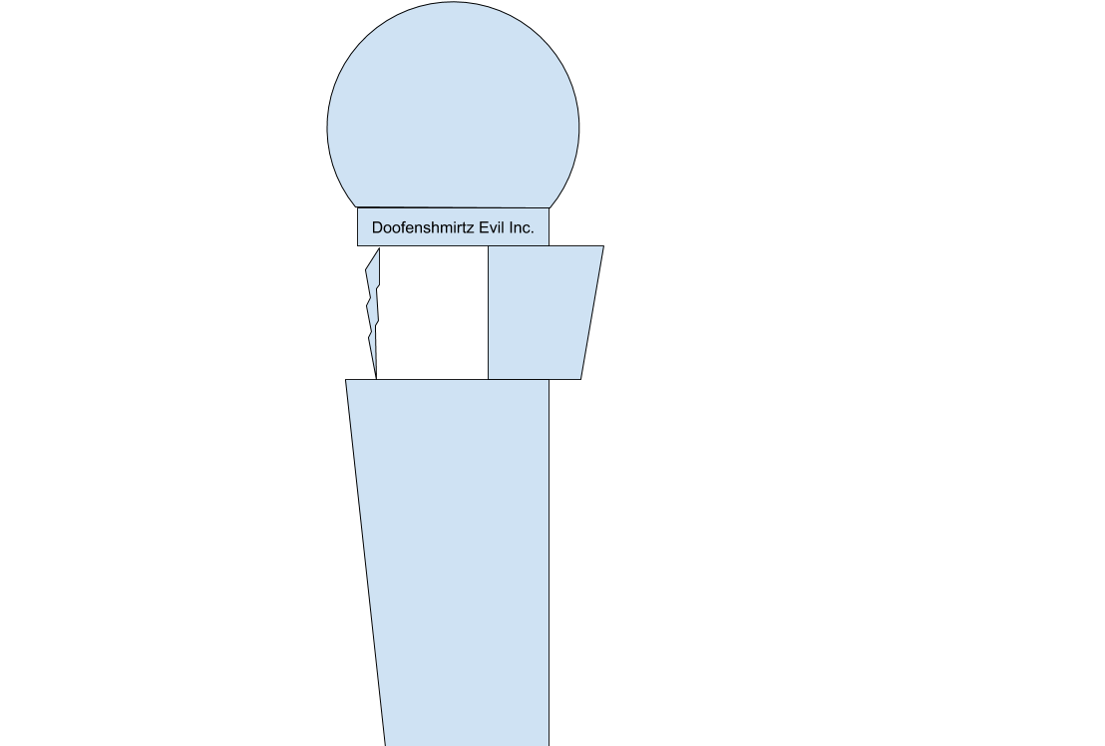

Include a task list--what will you need to do and in what order

1. Construct tower and a couple basic buildings surrounding it
2. Make the tower take off when it gets clicked on
3. Create a takeoff animation

Estimate the amount of time you will need to complete the project

1.5 weeks

**Construction – included in summary doc**

Document your construction progress with date and progress made (build a chart/table in word or excel), also, include at least three screen shots of your applet (beginning, middle, and end) See Daily Progress Report below.

**Testing/Results/Delivery—summary doc not required to start project**

Preliminary testing

Does your program meet the needs of the initial challenge or problem? How do you know?

Are any changes or modifications needed, why or why not? Document any changes.

Summarize the project - what worked, what didn’t work, note your successes and/or failures.

Looking back, would you have done anything differently, why or why not

Software Summary Document

The program meets the needs of the initial challenge/problem. It met the bare minimum as far as creating a city with an animation goes. No more modifications are necessary. Burning down buildings at a set height rate did not end up working, but deleting the entire building on click worked. Changing the cursor to a crosshair was also difficult, but manageable.

Looking back, I would probably have tried to figure out why deleting buildings gradually didn’t work if I had a lot more time, but that is just a preference. Also, seeing how it took much more than 1.5 weeks, I would probably create a more realistic timeline for my goal of project completion.

Daily Progress Report

|  |  |
| --- | --- |
| Date | Description |
| January 13, 2019 | Began making basic buildings |
| January 14, 2019 | Finished basic buildings outline, began doofenshmirtz tower |
| January 15, 2019 |  |
| January 16, 2019 | Added movable crosshair that replaces cursor (doesn’t show up when screenshotting) |
| January 19, 2019 | Buildings were animated and can move up and down |
| January 21, 2019 | began to make windows |
|  |  |
| January 26, 2019 | Click deletion of buildings work, but buildings end up not working, with only windows showing up to begin with. |
| January 30, 2019 | Building was figured out, everything complete. |